Pokhara University

Level: Bachelor | Semester – Spring | Year : 2005
Programme: BE |  | Full Marks : 100
Course: Engineering Mathematics II |  | Time : 3hrs.

Candidates are required to give their answers in their own words as far as practicable.
The figures in the margin indicate full marks.

Attempt all the questions.

1. | - Find the equation of the plane through the points (-1, 1,-1) and  (6, 2,1) normal to the plane 2x + y + z = 5.  OR  Find the shortest distance between the lines  ax + by + cz +d = 0 = a₁x +b₁y + c₁z + d, and z-axis.  - Find the equation of the spheres which pass through the circle  x² +y²+z²=5, x+2y+3z = 3 and touch the plane 4x+3y = 35. | 7  8
2. | - What do you mean by the maximum value of a function of two variables? Discuss the maxima or minima of the function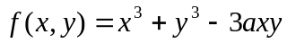. Also find the maximum or minimum value.  - State and prove Euler’s theorem for a homogeneous function of two variables x and y of degree n. Also verify Euler’s theorem for u = x² + xy + y² . | 7  8
3. | - Sketch the region of integration and evaluate by interchanging the order of integration 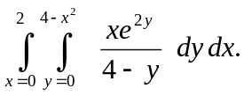  - Find the volume under the parabolic cylinder z = x² above the region bounded by the parabola y = 6 – x² and the line y = x in xy plane.  OR  Find the area bounded by the parabola x = y² – 1 and x =2y² – 2 by using double integration. | 7  8
4. | - Solve the following differential equation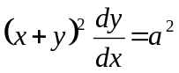.  - Solve: 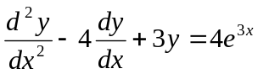. | 7  8
5. | - Solve y'' – 4y = 0 by power series method.  OR  Define Bessel function of the first kind. Also show that  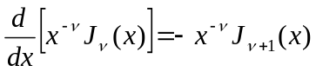  - Solve the initial value problem: y''- y' -2y = 3e^{2x} , y(0) = 0, y'(0) = -2 | 8  7
6. | - Evaluate the following:  - L (t² cosωt)  - L ⁻¹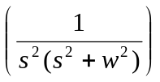  - Solve the following initial value problem by using Laplace transformation. y'' + 2y'+ 5y = 0, y(0) = 2, y'(0) = - 4. | 8  7
7. | Solve the followings:  - Show that (x²+xy²)dx + (x²y + y²)dy = 0 is exact.  - Find the equations of the line through (3,2,1) and perpendicular to the plane x + 2y + 2z + 4 = 0  - Write the standard equation of the cone containing x, y, and z axes as generators  - Find the Laplace transform of t e^{2t}.  - Find the integrating factor of 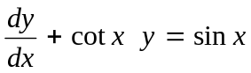. | 2  2  2  2  2

